

**Visualisation**

**Assignment3: (25%) Tableau Dashboard**

**Student Name:** Deepshikha Wadikar

**Student ID:** D17128916

You have been hired as a visualisation designer to design an effective **dashboard that enables a user to explore a dataset.**

1. Select a Dataset – 2%

2. Decide on an audience (user story) – 6%

* A problem - 2%
* A user - 2%
* A scenario - 2%

3. Using Tableau Public, design a Dashboard 12%

4. Show previous iterations or alternatives 5%

**--------------------------------------------------------------------------------------------------------**

1. **Links to the Dataset**

Data Scientist Job Market in the U.S in 2018 August overview.

Source:https[://www.kaggle.com/sl6149/data-scientist-job-market-in-the-us#alldata.csv](https://www.kaggle.com/sl6149/data-scientist-job-market-in-the-us#alldata.csv)

I have taken the dataset from Kaggle which is related to Data Scientist Job Market in the U.S in 2018.In this data set I have removed some null values columns and then I am using this dataset for visualisation.

The dataset comprises of 5 columns –

**Position** – It consists of various type of positions present in the company.

**Company** – Company column contains the various companies name which have vacancies in the Data Science/Data Analytics background.

**Description** – Displays the description of the job

**Reviews** – It shows the review ratings of the company

**Location** – It shows the location of the job/company in which the requirement is there.

1. **Description of audience (User, Problem, Scenario)**

**User –** I ama Data Analyst working in LinkedIn and need to prepare a visualisation dashboard to display the Job opportunities in Data Science/Data Analytics field in the US. This visualisation is helpful for the people who are looking for job as Data Scientist/Data Analyst. The main focus is only on the jobs related to as Data Scientist/Data Analyst.

**Problem –** While looking for job it happens with many people that they are not sure about the company reviews or the current job openings. They may miss out few of opportunities due to lack of information. This visualisation will help people to know the different job opportunities in Data Science/Data Analytics field. The visualisation will give a basic idea to the job seekers about the list of companies so that it would be easy for the person to shortlist the companies.

This visualisation also indicates that the Data Scientist jobs are highly in demand now-a-days.

**Scenario –** This dashboard is for all people who want to have information on the Data Science/Data Analytics job market.

This dashboard is useful for the following –

* Easy to know the job opportunities in Data Science and Analytics market
* Given an overview of different type of positions
* Portrays the demand of Data Science/Data Analytics market in US
* Easy to understand in one glance about the company and job position
* Easy to know the review of the companies
* Useful for students who wants to pursue higher education in the Data Science/Data Analytics field.

1. **Paste a Link to the Dashboard from Tableau Public**

<https://public.tableau.com/profile/deepshikha.wadikar#!/vizhome/Assignment3Tableau_3/FinalIteration?publish=yes>

1. **Paste screenshots of previous Iterations from Tableau Public**

The below screenshot is the iteration 1 screenshot

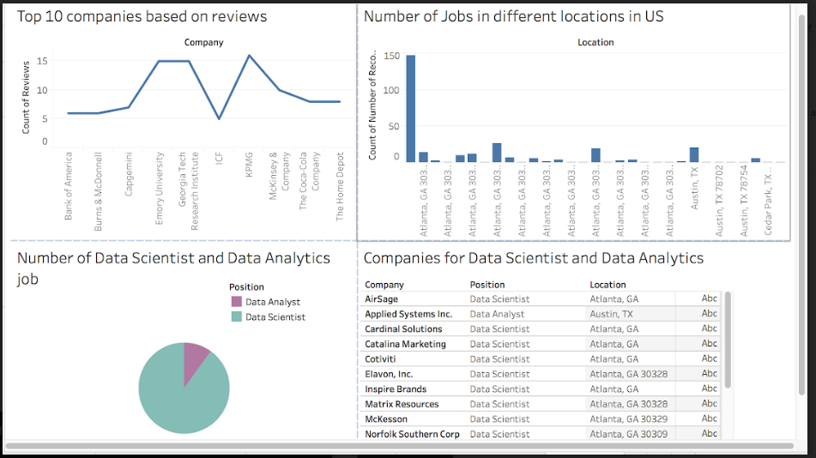

The below screenshot is the final iteration screenshot

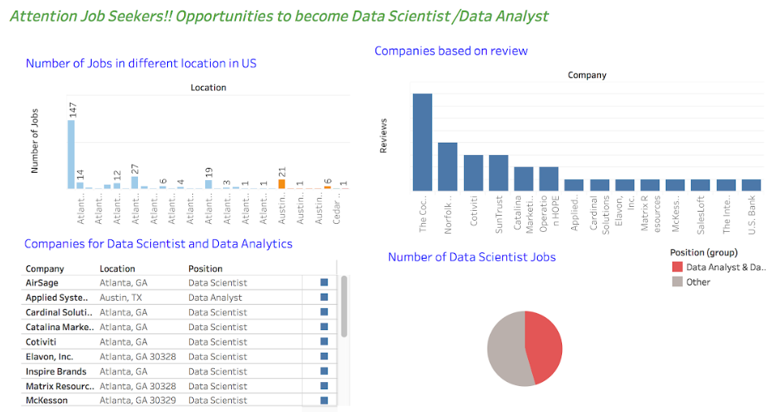

For this visualisation basically I have considered four charts:

* **Number of Jobs in different location in US**

In this chart the number of jobs in different locations are represented in the bar graph. In the first iteration the bars are represented in same colour and also count was not displayed.

This chart I have improved and divided the bars and given same colour to each location so by this just by looking into colour of the bars user can judge like there are maximum number of jobs in Atlanta location as we can see the blue colour the most, followed by Austin and so on.

* **Companies based on review**

In the first iteration I have showed the top 10 companies review but then in the final iteration I am considering the reviews of only those company who are offering Data Scientist and Data Analyst positions. Instead of line graph I am using bar chart because bar chart is easy to understand.

Also I have arranged the graph in increasing order which is providing a visual and just by looking into the bar height person can come to know like which is having maximum review and which companies have same review.

* **Number of Data Scientist Job**

Then in this graph in first iteration I was considering only Data Scientist and Data Analytics job but in the final iteration I am considering all jobs and based on that we can see a major chunk related to the position in Data Science/Data Analytics and the other portion is for the position in all other jobs.

* **Companies for Data Scientist and Data Analytics**

Then finally this is the chart in which it is depicting the Company, location and Position in different location. This chart is a direct information chart in which a brief information has been provided.

**----------------------------------------------------------------------------------------------------**